Github Steps

1. Create a repo on GitHub
2. Create Project directory on Local machine
3. Initialize project dir
   1. git init
   2. git add . (// add all files to the selected area)
   3. git commit –m “first commit”
   4. git remote add origin <https://github.com/soham-sketch/Web_dev.git>
   5. git branch –m Main
   6. git push –u origin Main
4. Create new branch for ‘new_login”
   1. git checkout –b login_feature
   2. add new files to the main branch
   3. git add .
   4. git –m commit “login_page_added”
   5. git push origin login_feature
5. merge branches
   1. git checkout main
   2. git merge abc.txt.txt

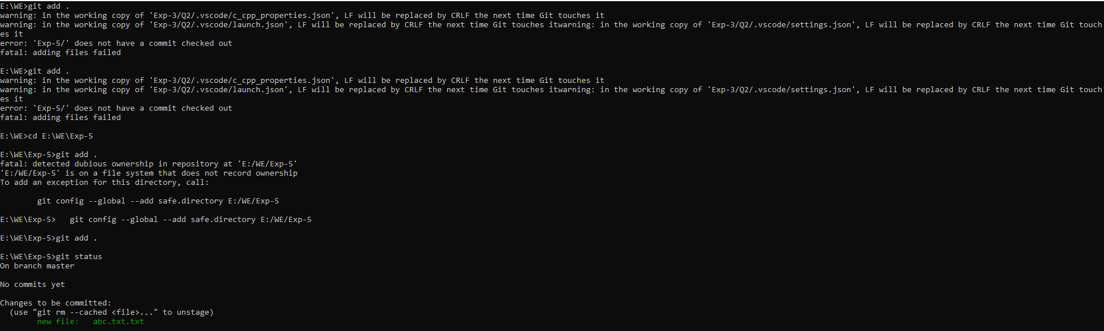

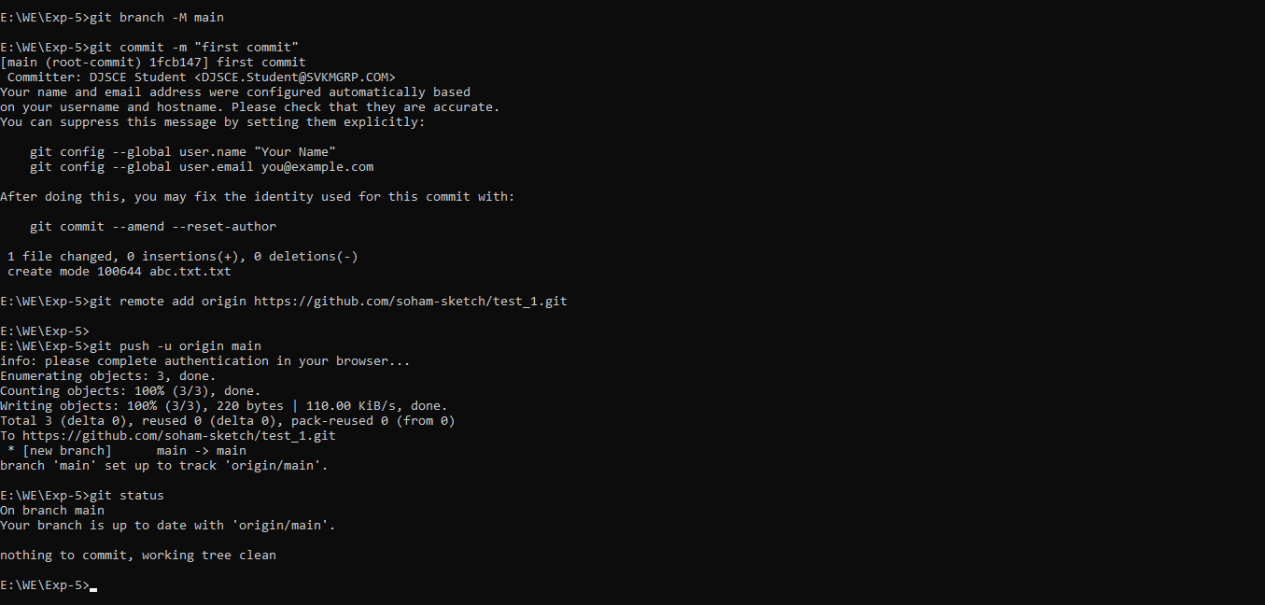

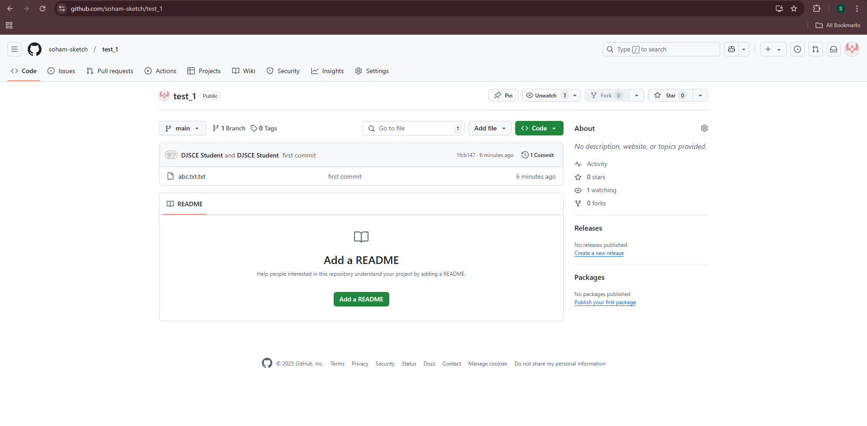

WriteUp:

